RETAIL MANAGEMENT APPLICATION USING SALESFORCE

1.INTRODUCTION

Salesforce can be used to manage orders from retail stores and distributors,including tracking orders,processing payments, and managing inventory levels.

1.1OVERVIEW

*Accounting for Management

*Economic Analysis

*Marketing Management

*Fundamentals of Retailing

*Business Communication

*Retail Branding

*Customer Relationship Marketing

1.2 PURPOSE

Retail management saves time and ensures the customers easily locate their desired merchandise and return home satisfied.An effective management avoid unnecessary chaos at the store.Effective Management controls shoplifting to a large extent.

2.PROBLEM DEFINITIN @ DESIGN THINKING

2.1 EMPATHY MAP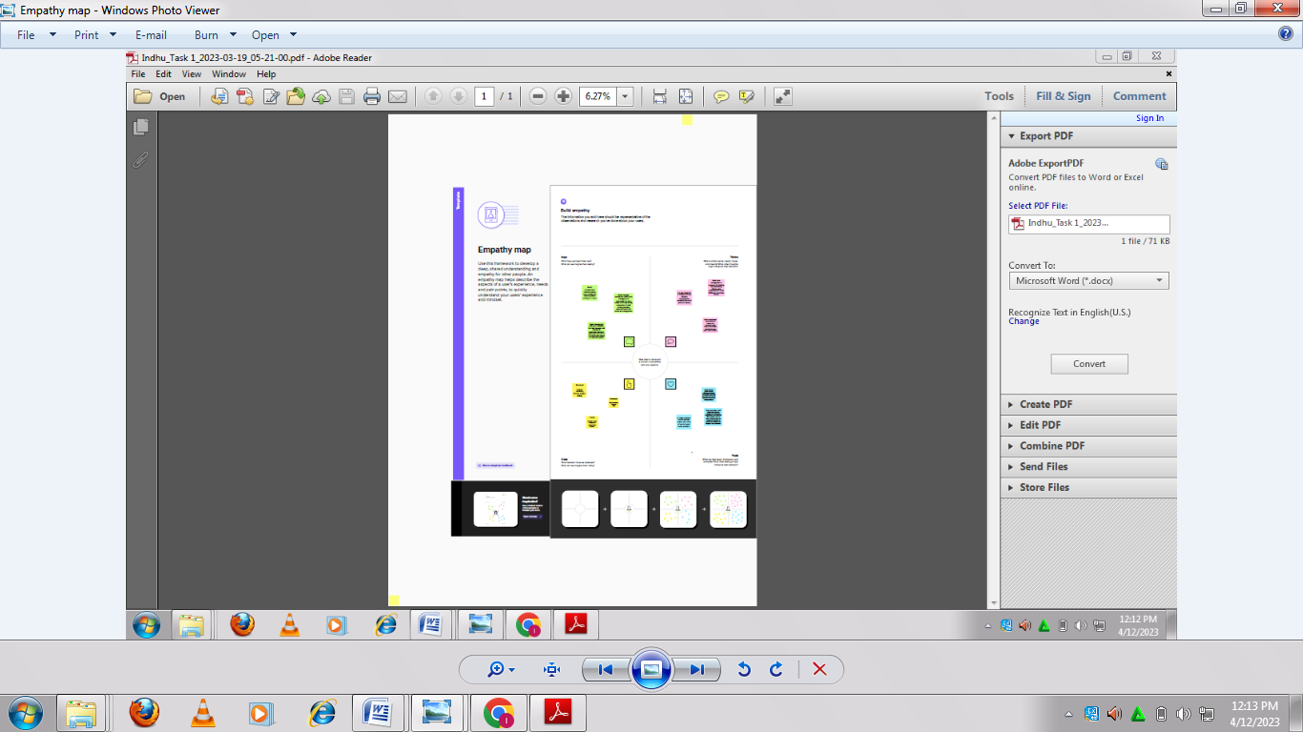

2.2 IDEATION & BRAINSTORMING MAP

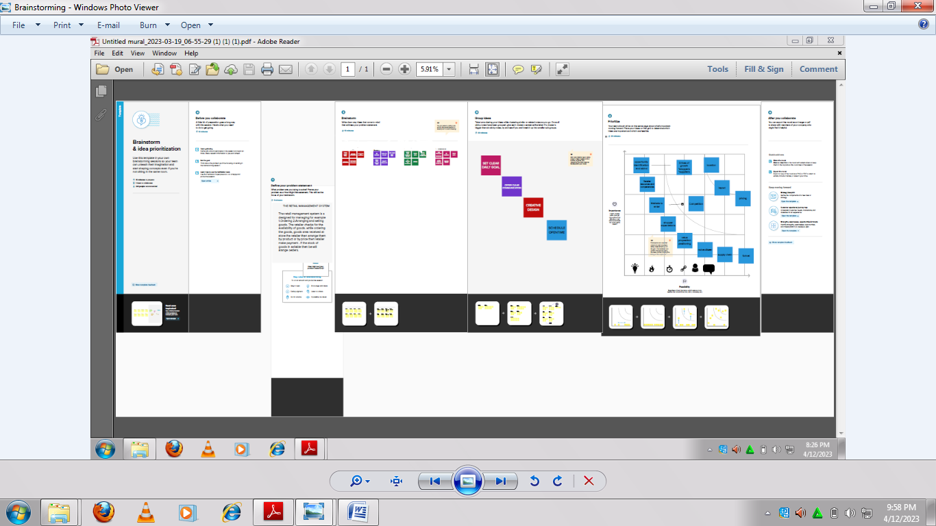

3.RESULT

3.1 Data Model

|  |  |
| --- | --- |
| Object name | Fields in the object |
| Obj1 | |  |  | | --- | --- | | Field label | Data type | | Display/tracking | text | |
| Obj2 | |  |  | | --- | --- | | Field label | Data type | | Dispatched | Checkbox | |

3.2 Activity & Screenshot

▪OBJECTS:

ACTIVITY-1

CREATION OF OBJECT DISPATCH/TRACKING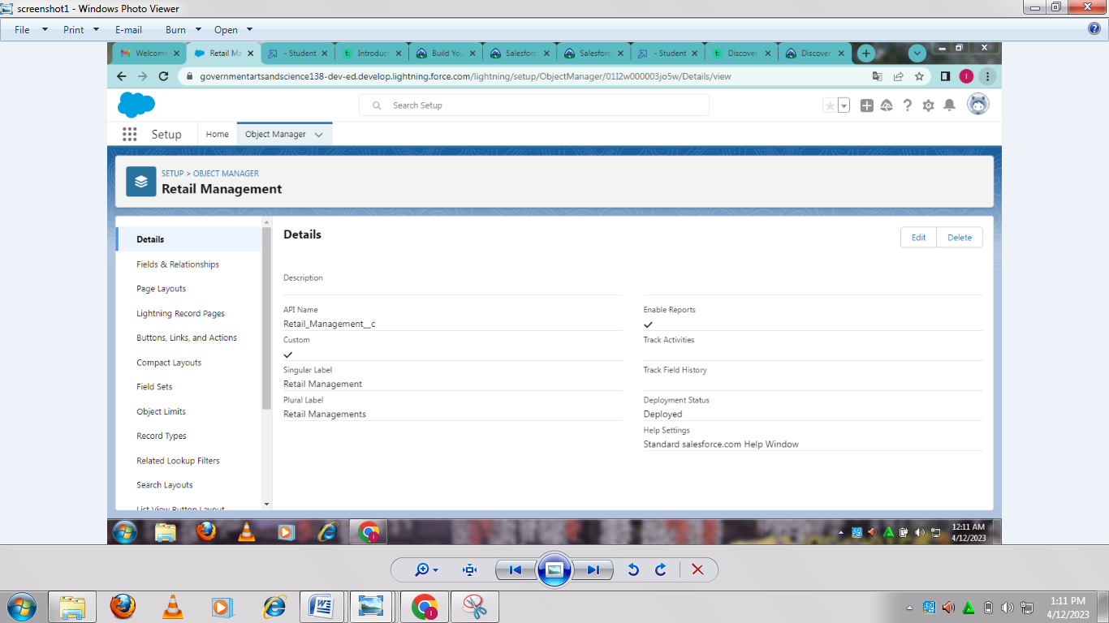

*The label name has Display/tracking.

*The Data type has test.

▪RELATIONSHIP B/W OBJECTS:

ACTIVITY-1:

CREATION OF RELATIONSHIPS BETWEEN OBJECTS

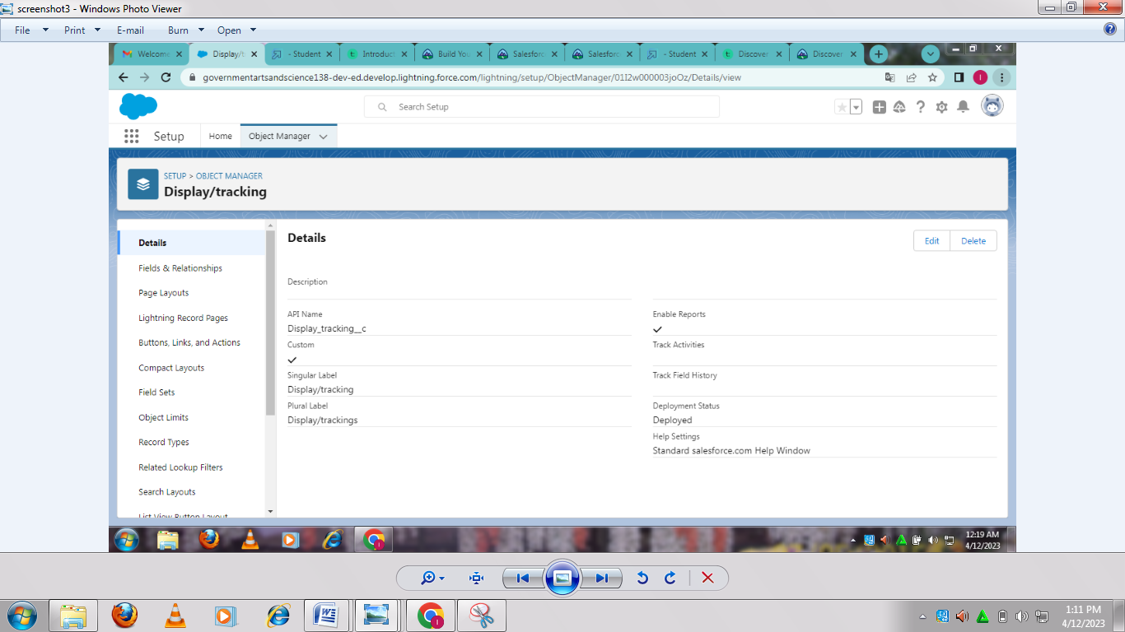

*Go to the object manager and select ‘Disptch/tracking’ object from the list.

*And select fields and relationship and click on new.

*Data type has Master detail relationship.

*Object has sales order.

ACTIVITY-2

FIELDS AVAILABLE ON DISPLAY/TRACKING

CREATION OF FIELDS ON DISPATCH/TRACKING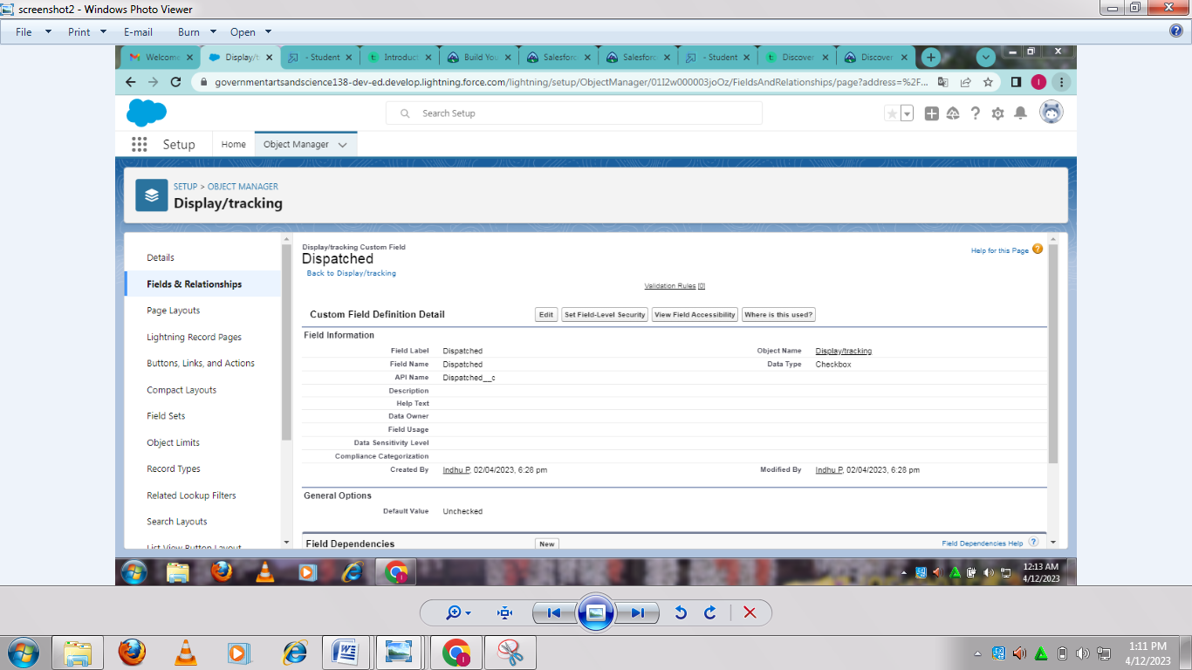

*Select your object from object selection has Dispatch/Tracking.

*Select the option fields and relationships.

*Now you have to select data type,Checkbox has data type.

*And give the label name has Dispatched.

▪LAYOUTS:

ACTIVITY:

CREATION OF CUSTOM TABS

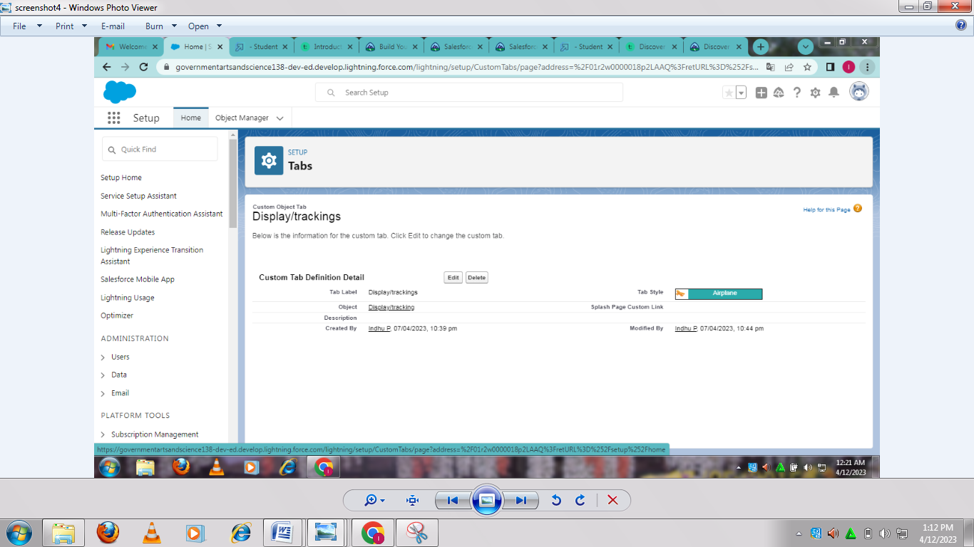

*Now create a cutom tab.

*For object,select Warehouset.

*For tab style,select any icon.

▪USER:

ACTIVITY-1

CREATION OF USER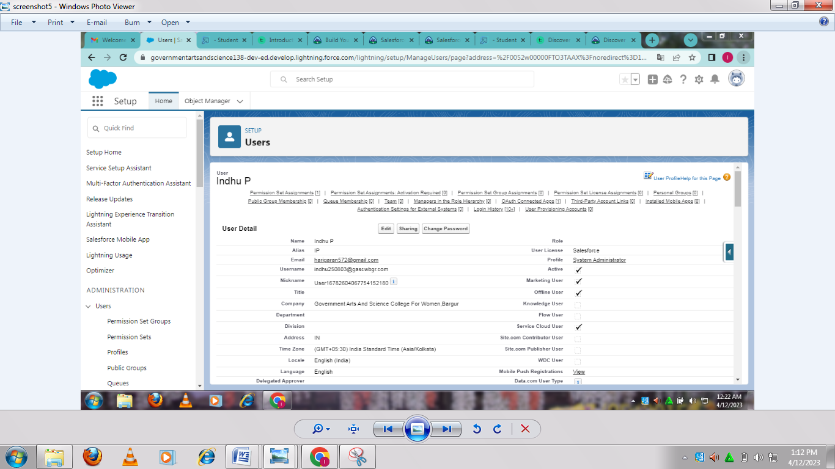

*Give first name and last name.

*Enter your email.

*And enter your details.

*And select standard platform profile.

▪VALIDATION RULES:

ACTIVITY-1:

CREATION OF VALIDATION RULE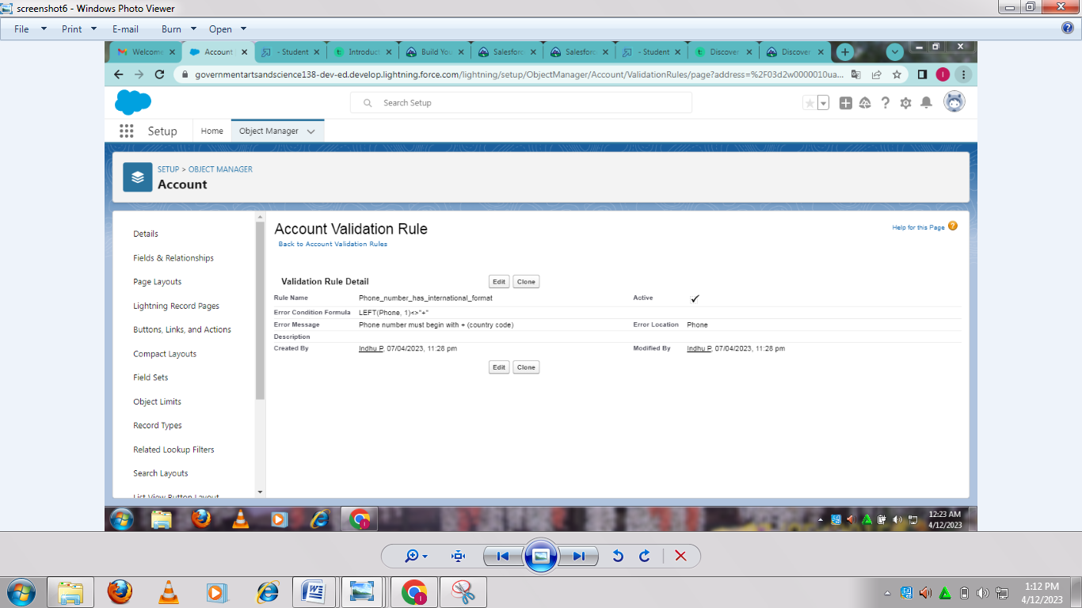

*Select Account object.

*And find validation rule in it.

*Formula has LEFT(Phone,1)<>”+”.

*Description has Phone number must begin with+(country code).

*In error location select top of the field.

ACTIVITY-2:

CROSS OBJECT FORMULA

CREATION OF CROSS OBJECT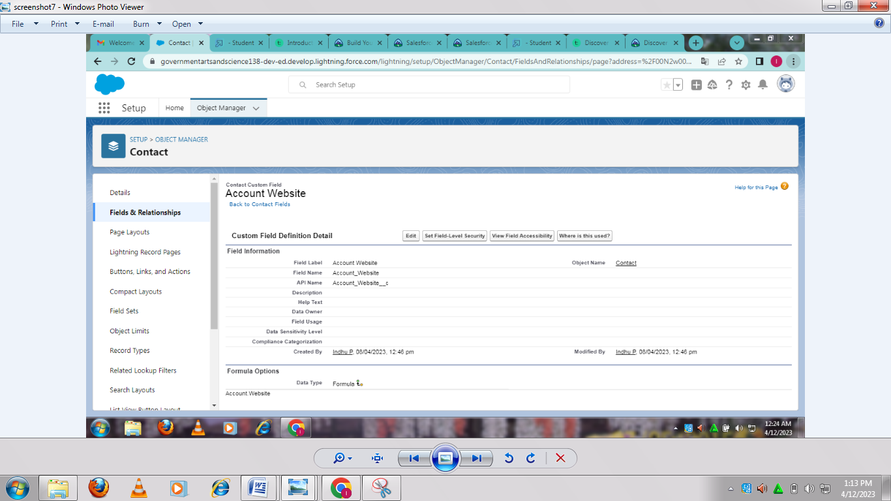

*Object selection has Contact.

*Data type has formula.

*Label name has Account Website.

*In the formula field enter this formula Account.Website.

▪REPORTS:

ACTIVITY:

CREATION OF REPORT

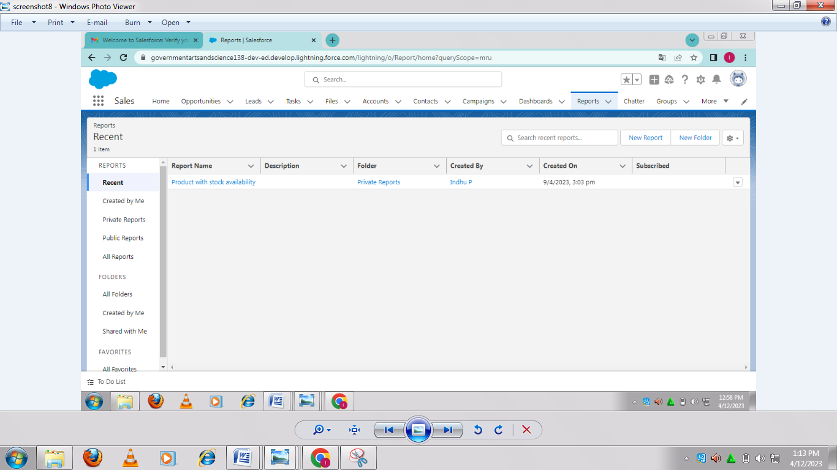

*Click on the app launcher and search for reports.

*Select Warehouses for the report type name.

*In outline pane,group rows select Product name and in columns warehouse name and stock available.

*And give the label name products with stock availability.

▪DASEBOARDS:

ACTIVITY:

CREATION OF DASHBOARD

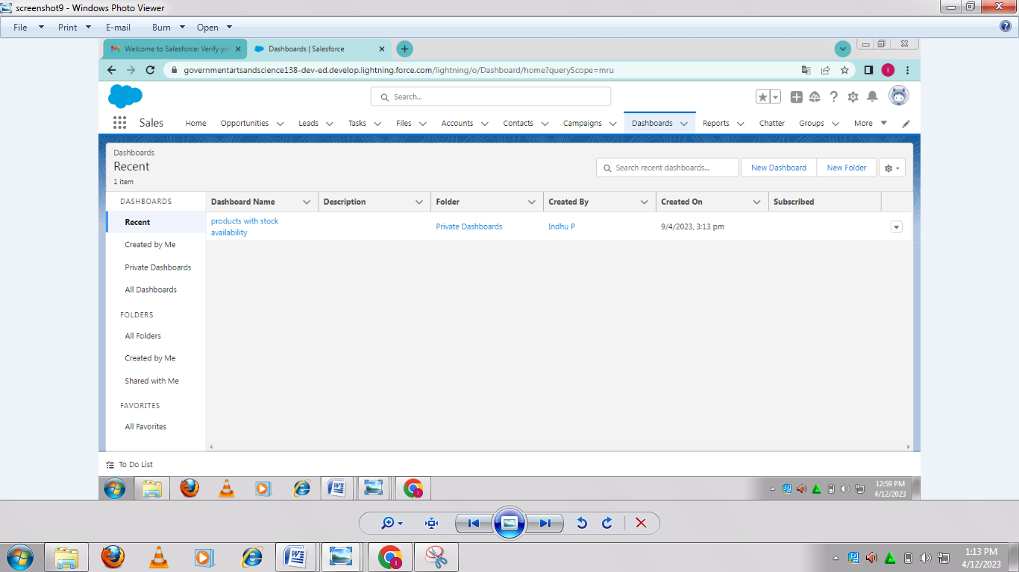

*Click on the app launcher and search for dashboards.

*Select the new dashboard option.

*Dashboard has products with stock availability.

*For report select Products with stock availability.

*Value is record count.

*Sliced by product name.

4.Trailhead Profile Public URL

Team Lead- <https://trailblazer.me/id/indhu1>

Team Member 1- [https://trailblazer.me/id/sowmm25](https://trailblazer.me/id/sowmm25%20%20)

Team Member 2-<https://trailblazer.me/id/navis25>

Team Member 3- <https://trailblazer.me/id/nands51>

5.ADVANTAGES & DISADVANTAGE

▪ADVANTAGES:

*Requires less capital

*More profit margin than wholesalers

*Better customers relation

*Credit facility

▪DISADVANTAGES:

*Requires more marketing costs

*Good selling skill is required

*High competition

6.APPLICATIONS

Retail management option of internal processes such as inventory management,offline and online storefronts,warehouse operations,payment and accounting and human resources.

7.CONCLUSION

Retail management refers to the process of helping customers find products in your store.It includes everything from increasing your customer pool to how products are presented,and how you fulfill a customer`s needs.A good store manager helps customers leave the store with a smile.

8.FUTURE SCOPE

Supervisory,sales,management,Administrative services and Client communication are all options for candidates with a retail management background.More than 2 million jobs are available in retail management around the world.